Data Handling and Visualization (DSA06)
Name: Prasanna M Reg. No: 1925260244
Set 23: Employee Performance Analysis
Question 1. In R, create a bar chart to visualize the distribution of employees across different departments. Label the chart elements.
Program (R):
library(ggplot2)
emp <- data.frame(Employee_ID = 1:5,
Department = c("Sales","HR","Marketing","Sales","HR"),
Years_of_Service = c(5,3,7,4,2),
Performance_Score = c(85,92,78,90,76))
ggplot(emp, aes(x = Department)) +
geom_bar(fill = "steelblue", colour = "black", width = 0.6) +
geom_text(stat = "count", aes(label = after_stat(count)), vjust = -0.3) +
labs(title = "Employees by Department", x = "Department", y = "Number of Employees") +
theme_minimal()
Output:
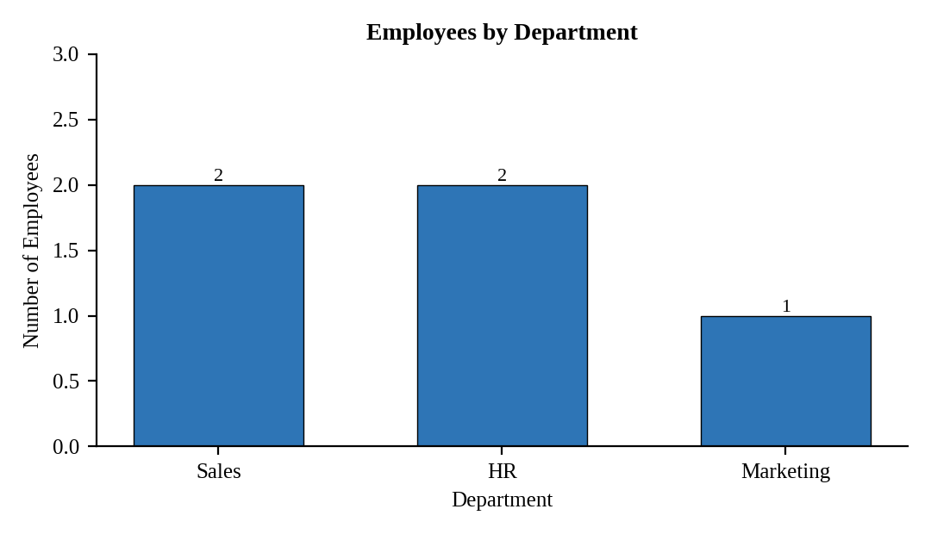
Interpretation:
Sales and HR have two employees each and Marketing has one. Sales and HR together account for 80% of the employees in the dataset.

Question 2. In R, generate a line chart to visualize the performance trend of employees over time. Label the axes and title the chart.
Assumed data: The dataset has no date field, so Years of Service is used as the time axis.
Program (R):
emp <- emp[order(emp$Years_of_Service), ]
ggplot(emp, aes(x = Years_of_Service, y = Performance_Score, group = 1)) +
geom_line(colour = "steelblue", linewidth = 1) + geom_point(size = 3) +
geom_text(aes(label = Performance_Score), vjust = -1) +
labs(title = "Performance Trend with Years of Service",
x = "Years of Service", y = "Performance Score") +
theme_minimal()
Output:
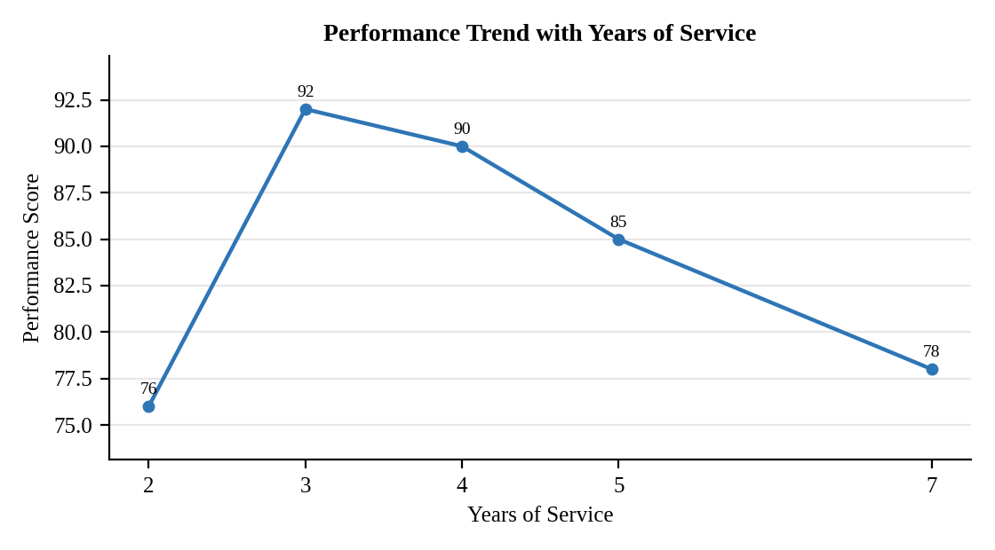
Interpretation:
Performance jumps from 76 at 2 years of service to a peak of 92 at 3 years, then declines steadily to 90, 85 and 78 at 4, 5 and 7 years. Employees in their early years of service perform best after the first year, and scores fall as service lengthens.

Question 3. In Tableau, build a dashboard combining a bar chart showing department distribution and a scatter plot displaying the relationship between years of service and performance scores.
Procedure (Tableau):
1. Open Tableau, click Connect, choose Text file / Microsoft Excel, select "Employee_Performance.csv" and open Sheet 1.
2. Sheet 1 (Bar): Columns = Department; Rows = COUNT(Employee ID); add labels.
3. Sheet 2 (Scatter): Columns = Years of Service (continuous, SUM); Rows = Performance Score (SUM); Color = Department; Detail = Employee ID; add a trend line (Analytics pane > Trend Line).
4. Click New Dashboard, name it "Employee Dashboard", set Size to Automatic and drag the sheets onto the canvas.
5. Select each chart and click the "Use as Filter" icon so that clicking a mark filters the other sheets; keep tooltips enabled.
6. Add a title to every sheet, adjust labels and colours, and save the workbook (File > Save As, .twbx).

Output:
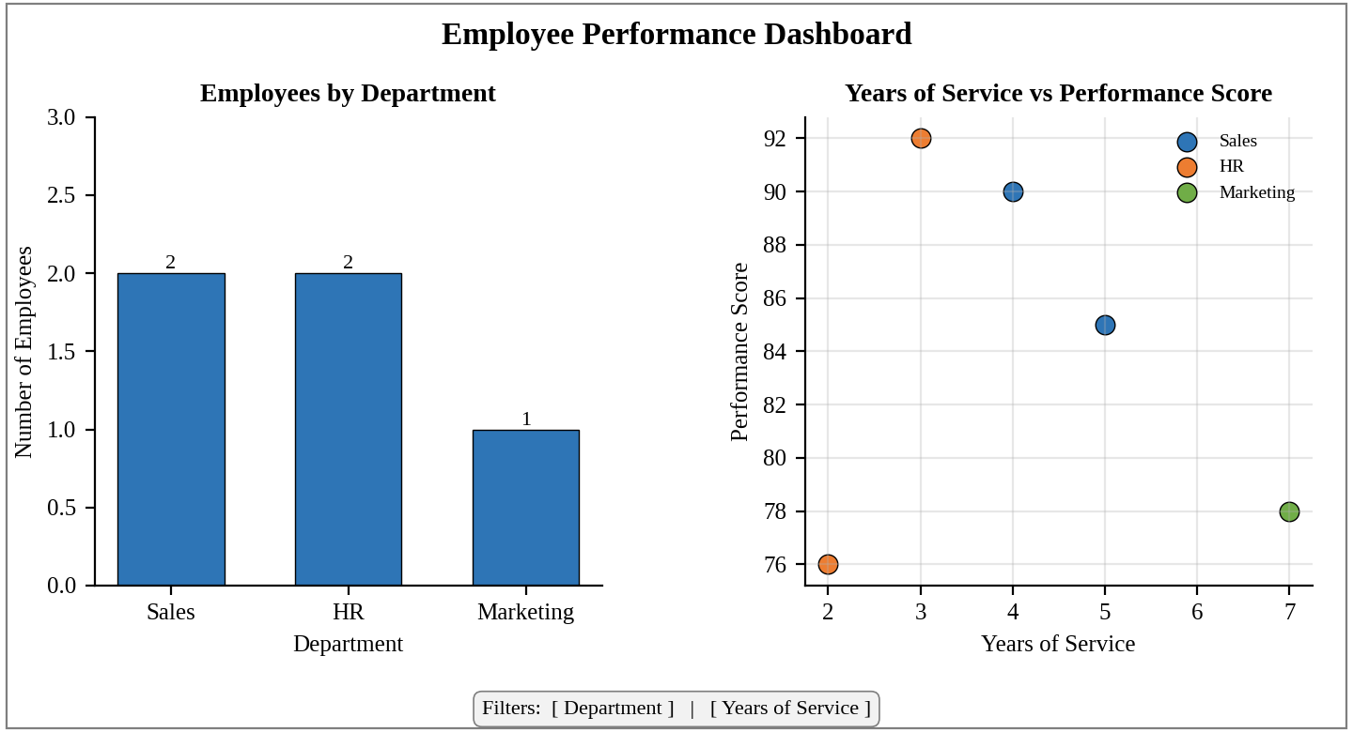
Dashboard layout (preview of the Tableau output).
Interpretation:
The scatter plot shows only a weak negative relationship between years of service and performance (r = -0.17); the pattern is not a straight line, because the best score (92) belongs to an employee with 3 years of service. Clicking a department bar filters the scatter plot to its employees, for example HR, whose two employees score 92 and 76.

Question 4. In R, develop a table showing the performance data for each employee. Label the table elements.
Program (R):
library(knitr)
kable(emp[order(emp$Employee_ID), ], align = "c", row.names = FALSE,
col.names = c("Employee ID","Department","Years of Service","Performance Score"),
caption = "Table 23.1: Employee Performance Data")
Output:
Table 23.1: Employee Performance Data
Employee ID | Department | Years of Service | Performance Score
1 | Sales | 5 | 85
2 | HR | 3 | 92
3 | Marketing | 7 | 78
4 | Sales | 4 | 90
5 | HR | 2 | 76

Interpretation:
The average performance score is 84.2 and the average service is 4.2 years. The highest score is 92 (Employee 2, HR) and the lowest is 76 (Employee 5, HR), so performance varies widely even within one department.

